Alarik Damrow

Professor Gevik Sardarbegians

CECS 346 Sec1 (7147)

1 November 2022

Project 2 Report: Drag Strip

This lab was done to present the demonstration of interrupts and how I can use them for the situation that was given for this lab. This lab was not difficult to develop the FSM and other functions to make the transitions happen but become difficult when the interrupts were needed for certain functions. Lots of reading was done from the manual and class book to have an understanding of how to trigger an interrupt and how to set a scenario for a certain interrupt.

GPIO Ports and Pins Table

|  |  |
| --- | --- |
| Description | Pin |
| Right Player Control | PA3 |
| Left Player Control | PA4 |
| Reset | PE0 |
| Right Player Bottom Yellow Light | PB0 |
| Right Player Upper Yellow Light | PB1 |
| Right Player Green Light | PB2 |
| Right Player Red Light | PB3 |
| Left Player Bottom Yellow Light | PB4 |
| Left Player Upper Yellow Light | PB5 |
| Left Player Green Light | PB6 |
| Left Player Red Light | PB7 |

Input Description of Ports and Pins

|  |  |
| --- | --- |
| Pin | Purpose |
| PA3 | Pin is responsible for capturing the response of the right player for this drag strip. Response is captured via a button that is set. Sensor variable is responsible in capturing the response from this pin as the program shows. |
| PA4 | Pin is responsible for capturing the response of the left player for this drag strip. Response is captured via a button that is set. Sensor variable is responsible for capturing the response in the program |
| PE0 | Pin is responsible in triggering the reset interrupt that is programed. No variable is specified for this pin but a interrupt and handler is set for this pin. |

Output Description of Ports and Pins

|  |  |
| --- | --- |
| Pin | Purpose |
| PB0 | This is the far bottom left yellow light and is turned on when output contains 0x11 or any variations that contains 0x11. Light variable is responsible for triggering this pin based on FSM[S].Out1 specification |
| PB4 | This is the far bottom right yellow light and is turned on when output contains 0x11 or any variations that contains 0x11. Light variable is responsible for triggering this pin based on FSM[S].Out1 specification |
| PB1 | This is the upper left yellow light and is turned on when output contains 0x22 or any variations that contains 0x22. Light variable is responsible for triggering this pin based on FSM[S].Out1 specification |
| PB5 | This is the upper right yellow light and is turned on when output contains 0x22 or any variations that contains 0x22. Light variable is responsible for triggering this pin based on FSM[S].Out1 specification |
| PB2 | This is the left green light and is turned on when output contains 0x44 or any variations that contains 0x44. Light variable is responsible for triggering this pin based on FSM[S].Out1 specification |
| PB6 | This is the right green light and is turned on when output contains 0x44 or any variations that contains 0x44. Light variable is responsible for triggering this pin based on FSM[S].Out1 specification |
| PB3 | This is the left red light and is turned on when output contains 0x88 or any variations that contains 0x88. Light variable is responsible for triggering this pin based on FSM[S].Out1 specification |
| PB7 | This is the right red light and is turned on when output contains 0x88 or any variations that contains 0x88. Light variable is responsible for triggering this pin based on FSM[S].Out1 specification |

State Table of FSM

States and what is done

|  |  |  |  |  |
| --- | --- | --- | --- | --- |
| Number | Name | Output | PB3-0 | PB7-4 |
| 0 | Init | 0xFF | Red, Yellow, Yellow, Green | Red, Yellow, Yellow, Green |
| 1 | Wait | 0x00 | None | None |
| 2 | Y1 | 0x11 | Yellow | Yellow |
| 3 | Y2 | 0x22 | Yellow | Yellow |
| 4 | Go | 0x44 | Green | Green |
| 5 | LR | 0x80 | Red | None |
| 6 | RR | 0x08 | None | Red |
| 7 | BR | 0x88 | Red | Red |
| 8 | LG | 0x40 | Green | None |
| 9 | RG | 0x04 | None | Green |
| 10 | BG | 0x44 | Green | Green |

States and the inputs

|  |  |  |  |  |  |
| --- | --- | --- | --- | --- | --- |
| Number | Name | Input = 0 | Input = 1 | Input = 2 | Input = 3 |
| 0 | Init | Wait | Wait | Wait | Wait |
| 1 | Wait | Wait | Wait | Wait | Y1 |
| 2 | Y1 | BR | LR | RR | Y2 |
| 3 | Y2 | BR | LR | RR | Go |
| 4 | Go | BG | LG | RG | Go |
| 5 | LR | Wait | Wait | Wait | Wait |
| 6 | RR | Wait | Wait | Wait | Wait |
| 7 | BR | Wait | Wait | Wait | Wait |
| 8 | LG | Wait | Wait | Wait | Wait |
| 9 | RG | Wait | Wait | Wait | Wait |
| 10 | BG | Wait | Wait | Wait | Wait |

FSM Diagram

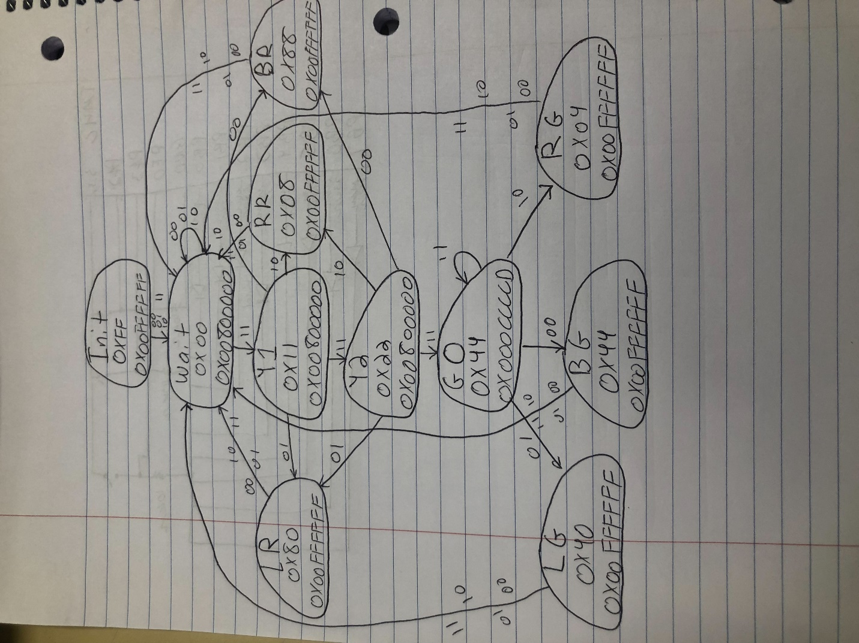

Photographs of Hardware

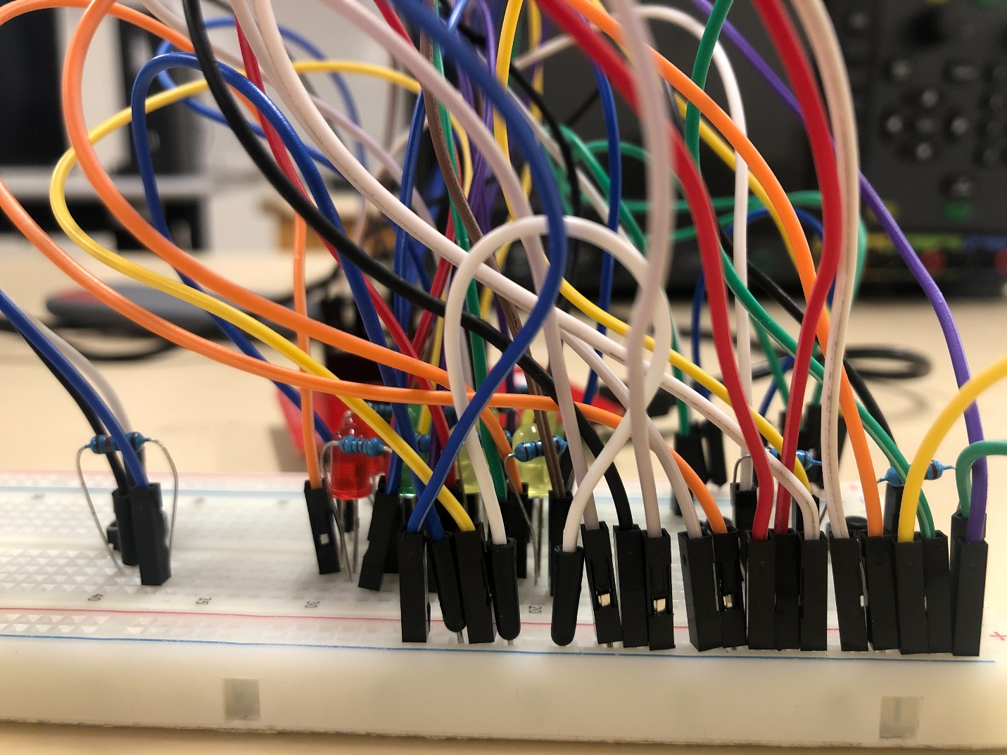

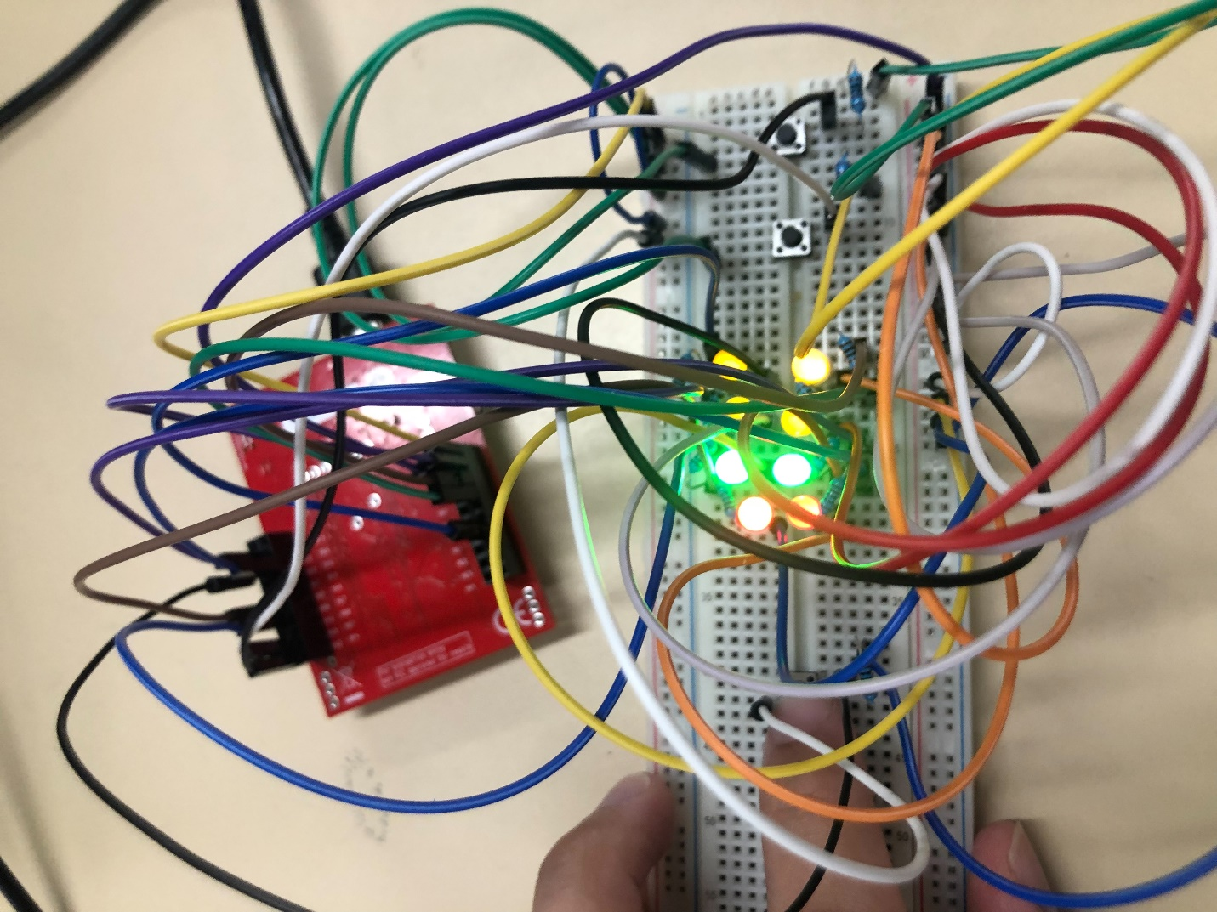

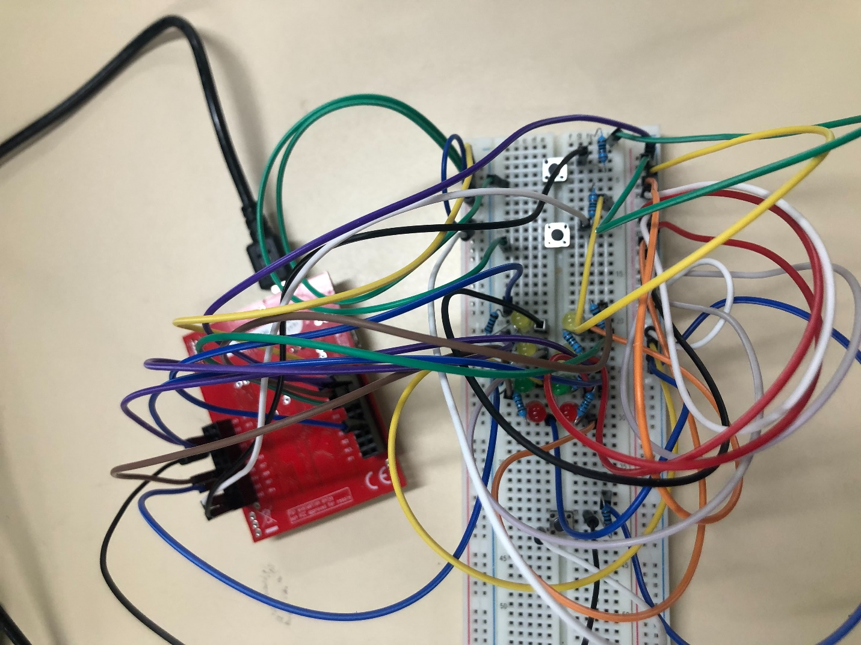

Hardware Diagram

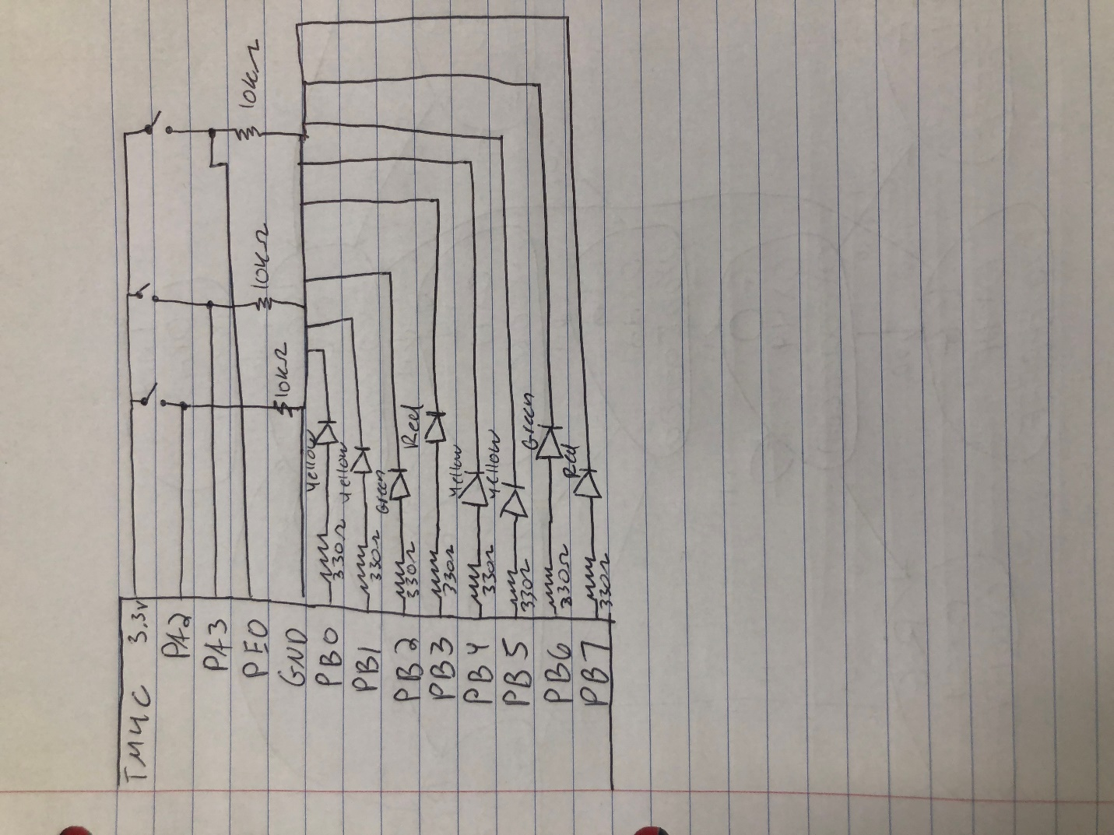

Analyzer Photos

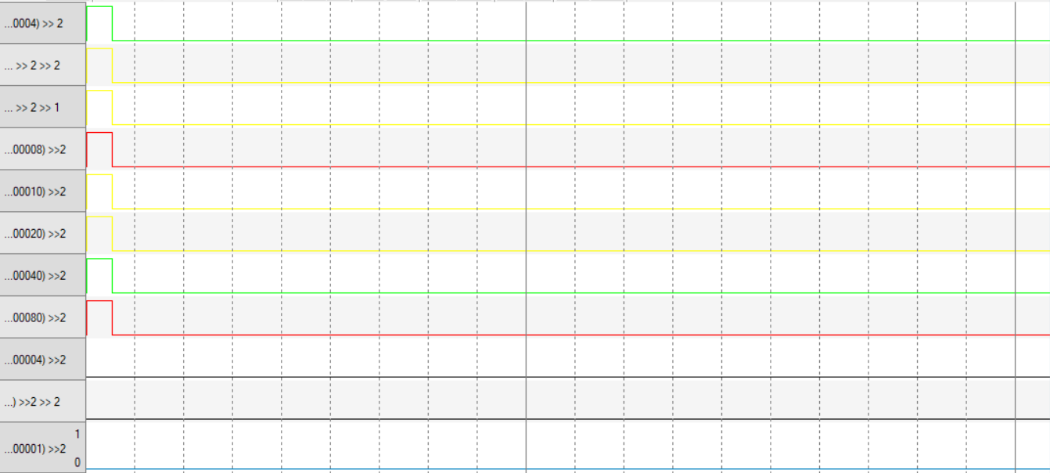

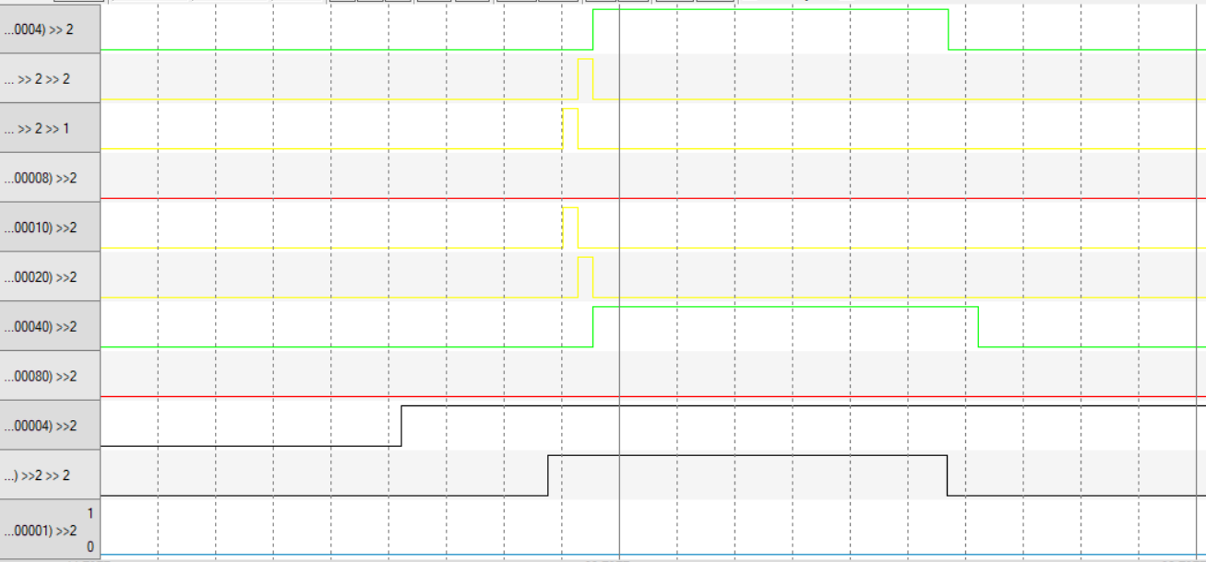

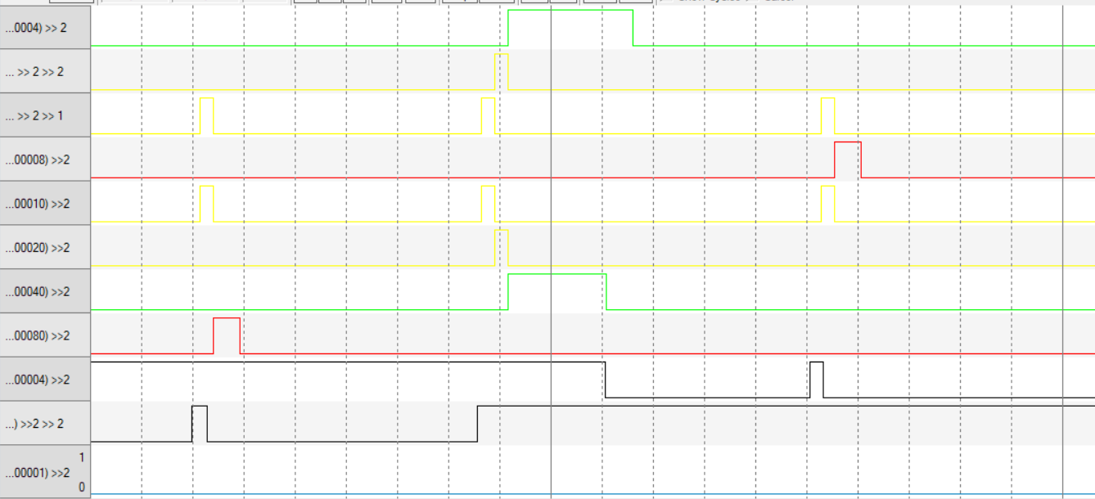

Source Code

//Port F

#define NVIC_EN0_R (*((volatile unsigned long *)0xE000E100)) // IRQ 0 to 31 Set Enable Register

#define NVIC_PRI7_R (*((volatile unsigned long *)0xE000E41C)) // IRQ 28 to 31 Priority Register

#define GPIO_PORTF_DIR_R (*((volatile unsigned long *)0x40025400))

#define GPIO_PORTF_IS_R (*((volatile unsigned long *)0x40025404))

#define GPIO_PORTF_IBE_R (*((volatile unsigned long *)0x40025408))

#define GPIO_PORTF_IEV_R (*((volatile unsigned long *)0x4002540C))

#define GPIO_PORTF_IM_R (*((volatile unsigned long *)0x40025410))

#define GPIO_PORTF_RIS_R (*((volatile unsigned long *)0x40025414))

#define GPIO_PORTF_ICR_R (*((volatile unsigned long *)0x4002541C))

#define GPIO_PORTF_AFSEL_R (*((volatile unsigned long *)0x40025420))

#define GPIO_PORTF_PUR_R (*((volatile unsigned long *)0x40025510))

#define GPIO_PORTF_PDR_R (*((volatile unsigned long *)0x40025514))

#define GPIO_PORTF_DEN_R (*((volatile unsigned long *)0x4002551C))

#define GPIO_PORTF_AMSEL_R (*((volatile unsigned long *)0x40025528))

#define GPIO_PORTF_PCTL_R (*((volatile unsigned long *)0x4002552C))

#define SYSCTL_RCGC2_R (*((volatile unsigned long *)0x400FE108))

#define SYSCTL_RCGC2_GPIOF 0x00000020 // port F Clock Gating Control

#include "tm4c123gh6pm.h"

#include <stdint.h>

//Port F

#define GPIO_PORTF_DATA_R (*((volatile unsigned long *)0x400253FC))

#define GPIO_PORTF_DIR_R (*((volatile unsigned long *)0x40025400))

#define GPIO_PORTF_AFSEL_R (*((volatile unsigned long *)0x40025420))

#define GPIO_PORTF_PUR_R (*((volatile unsigned long *)0x40025510))

#define GPIO_PORTF_DEN_R (*((volatile unsigned long *)0x4002551C))

#define GPIO_PORTF_LOCK_R (*((volatile unsigned long *)0x40025520))

#define GPIO_PORTF_CR_R (*((volatile unsigned long *)0x40025524))

#define GPIO_PORTF_AMSEL_R (*((volatile unsigned long *)0x40025528))

#define GPIO_PORTF_PCTL_R (*((volatile unsigned long *)0x4002552C))

#define GPIO_LOCK_KEY 0x4C4F434B

//Port B

#define GPIO_PORTB_OUT (*((volatile unsigned long *)0x400053FC)) // bits 7-0

#define GPIO_PORTB_DIR_R (*((volatile unsigned long *)0x40005400))

#define GPIO_PORTB_AFSEL_R (*((volatile unsigned long *)0x40005420))

#define GPIO_PORTB_DEN_R (*((volatile unsigned long *)0x4000551C))

#define GPIO_PORTB_AMSEL_R (*((volatile unsigned long *)0x40005528))

#define GPIO_PORTB_PCTL_R (*((volatile unsigned long *)0x4000552C))

//Port A

#define GPIO_PORTA_IN (*((volatile unsigned long *)0x400043FC)) // bits 4-2

#define GPIO_PORTA_DATA_R (*((volatile unsigned long *)0x400043FC))

#define GPIO_PORTA_DIR_R (*((volatile unsigned long *)0x40004400))

#define GPIO_PORTA_AFSEL_R (*((volatile unsigned long *)0x40004420))

#define GPIO_PORTA_PUR_R (*((volatile unsigned long *)0x40004510))

#define GPIO_PORTA_DEN_R (*((volatile unsigned long *)0x4000451C))

#define GPIO_PORTA_LOCK_R (*((volatile unsigned long *)0x40004520))

#define GPIO_PORTA_CR_R (*((volatile unsigned long *)0x40004524))

#define GPIO_PORTA_AMSEL_R (*((volatile unsigned long *)0x40004528))

#define GPIO_PORTA_PCTL_R (*((volatile unsigned long *)0x4000452C))

#define GPIO_PORTA_ODR_R (*((volatile unsigned long *)0x4000450C))

#define GPIO_PORTA_IS_R (*((volatile unsigned long *)0x40004404))

#define GPIO_PORTA_IBE_R (*((volatile unsigned long *)0x40004408))

#define GPIO_PORTA_ICR_R (*((volatile unsigned long *)0x4000441C))

#define GPIO_PORTA_IM_R (*((volatile unsigned long *)0x40004410))

#define NVIC_PRI0_R (*((volatile unsigned long *)0xE000E400))

//Port E

#define GPIO_PORTE_DATA_R (*((volatile unsigned long *)0x400243FC))

#define GPIO_PORTE_DIR_R (*((volatile unsigned long *)0x40024400))

#define GPIO_PORTE_AFSEL_R (*((volatile unsigned long *)0x40024420))

#define GPIO_PORTE_PUR_R (*((volatile unsigned long *)0x40024510))

#define GPIO_PORTE_DEN_R (*((volatile unsigned long *)0x4002451C))

#define GPIO_PORTE_LOCK_R (*((volatile unsigned long *)0x40024520))

#define GPIO_PORTE_CR_R (*((volatile unsigned long *)0x40024524))

#define GPIO_PORTE_AMSEL_R (*((volatile unsigned long *)0x40024528))

#define GPIO_PORTE_PCTL_R (*((volatile unsigned long *)0x4002452C))

#define GPIO_PORTE_ODR_R (*((volatile unsigned long *)0x4002450C))

#define GPIO_PORTE_IS_R (*((volatile unsigned long *)0x40024404))

#define GPIO_PORTE_IBE_R (*((volatile unsigned long *)0x40024408))

#define GPIO_PORTE_ICR_R (*((volatile unsigned long *)0x4002441C))

#define GPIO_PORTE_IM_R (*((volatile unsigned long *)0x40024410))

#define NVIC_PRI1_R (*((volatile unsigned long *)0xE000E404))

//SysTick Interrupts

#define NVIC_SYS_PRI3_R (*((volatile unsigned long *)0xE000ED20))

#define NVIC_ST_CTRL_R (*((volatile unsigned long *)0xE000E010))

#define NVIC_ST_RELOAD_R (*((volatile unsigned long *)0xE000E014))

#define NVIC_ST_CURRENT_R (*((volatile unsigned long *)0xE000E018))

#define NVIC_EN0_R (*((volatile unsigned long *)0xE000E100))

#define SYSCTL_RCGC2_R (*((volatile unsigned long *)0x400FE108))

#define SENSOR (*((volatile unsigned long *)0x40004030)) // Port A for buttons

#define RSENSOR (*((volatile unsigned long *)0x40024004))

#define RESET (*((volatile unsigned long *)0x40025004)) // Port F for buttons

#define LIGHT (*((volatile unsigned long *)0x400053FC)) // Port B for LEDs

#define SYSCTL_RCGC2_GPIOB 0x00000002 // port B Clock Gating Control

#define SYSCTL_RCGC2_GPIOA 0x00000001 // port A Clock Gating Control

#define SYSCTL_RCGC2_GPIOF 0x00000020 // port F Clock Gating Control

#define SYSCTL_RCGC2_GPIOE 0x00000010 // port F Clock Gating Control

void DisableInterrupts(void); // Disable interrupts

void EnableInterrupts(void); // Enable interrupts

long StartCritical (void); // previous I bit, disable interrupts

void EndCritical(long sr); // restore I bit to previous value

void WaitForInterrupt(void); // low power mode

void Ports_Init(void);

void SysTick_Init(unsigned long period);

void SysTick_Handler (void);

void GPIOPortA_Handler(void);

void GPIOPortE_Handler(void);

// global variable visible in Watch window of debugger

// increments at least once per button press

struct State {

unsigned long Out1;

unsigned long Time;

unsigned long Next[4];};

typedef const struct State STyp;

#define Init 0

#define Wait 1

#define Y1 2

#define Y2 3

#define Go 4

#define LR 5

#define RR 6

#define BR 7

#define LG 8

#define RG 9

#define BG 10

STyp FSM[11]={

{0xFF,0x00FFFFFF,{Wait,Wait,Wait,Wait}},

{0x00,0x00800000,{Wait,Wait,Wait,Y1}},

{0x11,0x00800000,{BR,LR,RR,Y2}},

{0x22,0x00800000,{BR,LR,RR,Go}},

{0x44,0x000CCCCD,{BG,LG,RG,Go}},

{0x80,0x00FFFFFF,{Wait,Wait,Wait,Wait}},

{0x08,0x00FFFFFF,{Wait,Wait,Wait,Wait}},

{0x88,0x00FFFFFF,{Wait,Wait,Wait,Wait}},

{0x40,0x00FFFFFF,{Wait,Wait,Wait,Wait}},

{0x04,0x00FFFFFF,{Wait,Wait,Wait,Wait}},

{0x44,0x00FFFFFF,{Wait,Wait,Wait,Wait}}

};

unsigned long S; // index to the current state

unsigned long Input;

unsigned long In1;

void EdgeCounter_Init(void){

DisableInterrupts();//EnableInterrupts(); // (i) Clears the I bit

//Port E

GPIO_PORTE_IS_R &= ~0x01; // (d) PF4 is edge-sensitive

GPIO_PORTE_IBE_R &= ~0x01; // PF4 is not both edges

GPIO_PORTE_ICR_R = 0x01; // (e) clear flag

GPIO_PORTE_IM_R |= 0x01; // (f) arm interrupt on PE1

NVIC_PRI1_R = (NVIC_PRI7_R&0xFF00FFFF)|0x00200000; // (g) priority 1

//Port A

GPIO_PORTA_IS_R &= ~0x0C; // (d) PF4 is edge-sensitive

GPIO_PORTA_IBE_R &= 0x0C; // PF4 is not both edges

GPIO_PORTA_ICR_R = 0x0C; // (e) clear flag

GPIO_PORTA_IM_R |= 0x0C; // (f) arm interrupt on PA2-3

NVIC_PRI1_R = (NVIC_PRI7_R&0xFF00FFFF)|0x00400000; // (g) priority 2

NVIC_EN0_R |= 0x00000011;

EnableInterrupts();

}

//debug code

int main(void){

Ports_Init();

EdgeCounter_Init();

S = Init;

LIGHT = FSM[S].Out1;

SysTick_Init(FSM[S].Time);

while(1)

{

WaitForInterrupt();

}

}

void Ports_Init(void){

volatile unsigned long delay;

SYSCTL_RCGC2_R = 0x33; // 1) A B E F

delay = SYSCTL_RCGC2_R; // 2) no need to unlock

//Port A

GPIO_PORTA_DATA_R = 0x400043FC;

GPIO_PORTA_CR_R = 0x1C;

GPIO_PORTA_AMSEL_R &= 0x00; // 3) disable analog function on PA3-2

GPIO_PORTA_PCTL_R &= 0x00000000; // 4) enable regular GPIO

GPIO_PORTA_DIR_R &= 0x00; // 5) inputs on PA3-2

GPIO_PORTA_AFSEL_R &= 0x00; // 6) regular function on PA3-2

GPIO_PORTA_DEN_R |= 0x0C; // 7) enable digital on PA3-2

GPIO_PORTA_ODR_R |= 0x38;

//Port F

GPIO_PORTF_LOCK_R = 0x4C4F434B; // 2) unlock GPIO Port F

GPIO_PORTF_CR_R = 0x1F; // allow changes to PF4-0

GPIO_PORTF_AMSEL_R = 0x00; // 3) disable analog on PF

GPIO_PORTF_PCTL_R = 0x00000000; // 4) PCTL GPIO on PF4-0

GPIO_PORTF_DIR_R = 0x0E; // 5) PF4,PF0 in, PF3-1 out

GPIO_PORTF_AFSEL_R = 0x00; // 6) disable alt funct on PF7-0

GPIO_PORTF_PUR_R = 0x11; // enable pull-up on PF0 and PF4

GPIO_PORTF_DEN_R = 0x1F; // 7) enable digital I/O on PF4-0

//Port B

GPIO_PORTB_AMSEL_R &= ~0xFF;

GPIO_PORTB_PCTL_R &= ~0x00FFFFFF; // 4) enable regular GPIO

GPIO_PORTB_DIR_R |= 0xFF; // 5) outputs on PB5-0

GPIO_PORTB_AFSEL_R &= ~0xFF; // 6) regular function on PB5-0

GPIO_PORTB_DEN_R |= 0xFF; // 7) enable digital on PB5-0

//Port E

GPIO_PORTE_CR_R |= 0x01;

GPIO_PORTE_AMSEL_R &= ~0x01; // 3) disable analog function on PE1

GPIO_PORTE_PCTL_R &= 0x00000000; // 4) enable regular GPIO

GPIO_PORTE_DIR_R &= ~0x01; // 5) inputs on PE1

GPIO_PORTE_AFSEL_R &= ~0x01; // 6) regular function on PE1

GPIO_PORTE_DEN_R |= 0x01; // 7) enable digital on PE1

}

void SysTick_Init(unsigned long period) {

NVIC_ST_CTRL_R = 0; //disable SysTick during setup

NVIC_ST_RELOAD_R = period-1; //reload value

NVIC_ST_CURRENT_R = 0; //any write to current clears it

NVIC_SYS_PRI3_R = (NVIC_SYS_PRI3_R&0x00FFFFFF) | 0x60000000; // priority 3

NVIC_ST_CTRL_R = 0x07;

EnableInterrupts();

}

void SysTick_Handler() {

In1 = SENSOR >> 2; // read sensors

Input = In1;

S = FSM[S].Next[Input];

LIGHT = FSM[S].Out1; // set lights

SysTick_Init(FSM[S].Time);

}

void GPIOPortA_Handler()

{

GPIO_PORTA_ICR_R = 0x0C;

}

void GPIOPortE_Handler()

{

GPIO_PORTE_ICR_R = 0x01;

S = Init;

LIGHT = FSM[S].Out1;

SysTick_Init(FSM[S].Time);

}